Question 1 Notes

Question 1 A
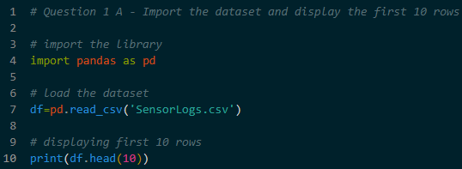
- Using Pandas library to bring the data into Python
- Use read_csv to load the file and head(10) to look at the first ten rows

Question 1 B
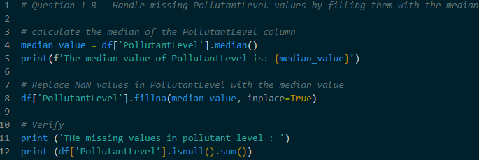
- Data often has empty cells (NaN). To make data useful, fill it these empty cells with the .median() value of the column
- Using the median because it is the middle number and is not affected by extremely high or low numbers

Question 1 C
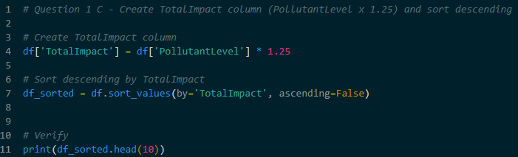
- Creating a new column called TotalImpact multiplying the PollutantLevel by 1.25
- After the calculation, sort the entire list from the highest impact to the lowest impact using ascending=False

Question 1 D
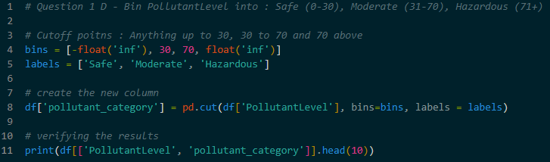
- Binning means – grouping numbers into categories
- Defining specific ranges (0-30, 31-70, 71+) and give them labels (Safe, Moderate, Hazardous)
- The pd.cut is used for this task

Question 1 E
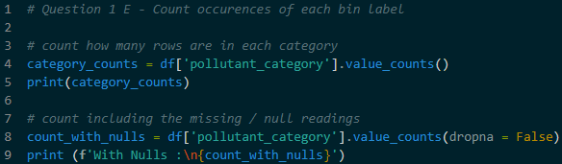
- Counting how many sensor readings fall into each category after grouping the data
- This shows us the frequency of each environmental status
- The value_counts() function automatically totals each label for us

Question 1 F
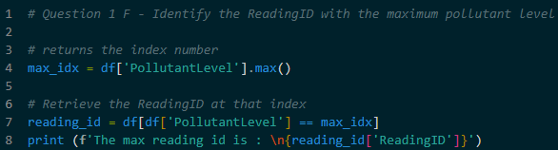
- Find which specific ReadingID recorded the highest pollution level
- Using max() to find the maximum value and then looking up the ID associated with that index

Key Rules to Remember
- Inplace : Most Pandas actions create a copy. It must save the result back to df to keep the changes
- Case Sensitivity : PollutantLevel is different from pollutantlevel. Always match the file exactly
- Missing Data : Always handle empty cells before doing calculations, or the math results will be empty too

